Brainstorm & Idea Prioritization Phase

| Date | 27-06-2025 |
| --- | --- |
| Team ID | LTVIP2025TMID58018 |
| Project Name | Freelance Finder |
| Maximum Marks | 4 Marks |

# Brainstorm & Idea Prioritization Phase

Brainstorming enables teams to collaboratively generate creative solutions. The Freelance Finder team engaged in a three-step ideation process: team collaboration, idea generation, and idea prioritization. This report outlines each phase and its outcomes.

## Step 1: Team Gathering, Collaboration and Problem Statement Selection

"Freelancers and clients often face difficulties in discovering suitable opportunities or talent due to a lack of centralized, trusted, and feature-rich platforms."

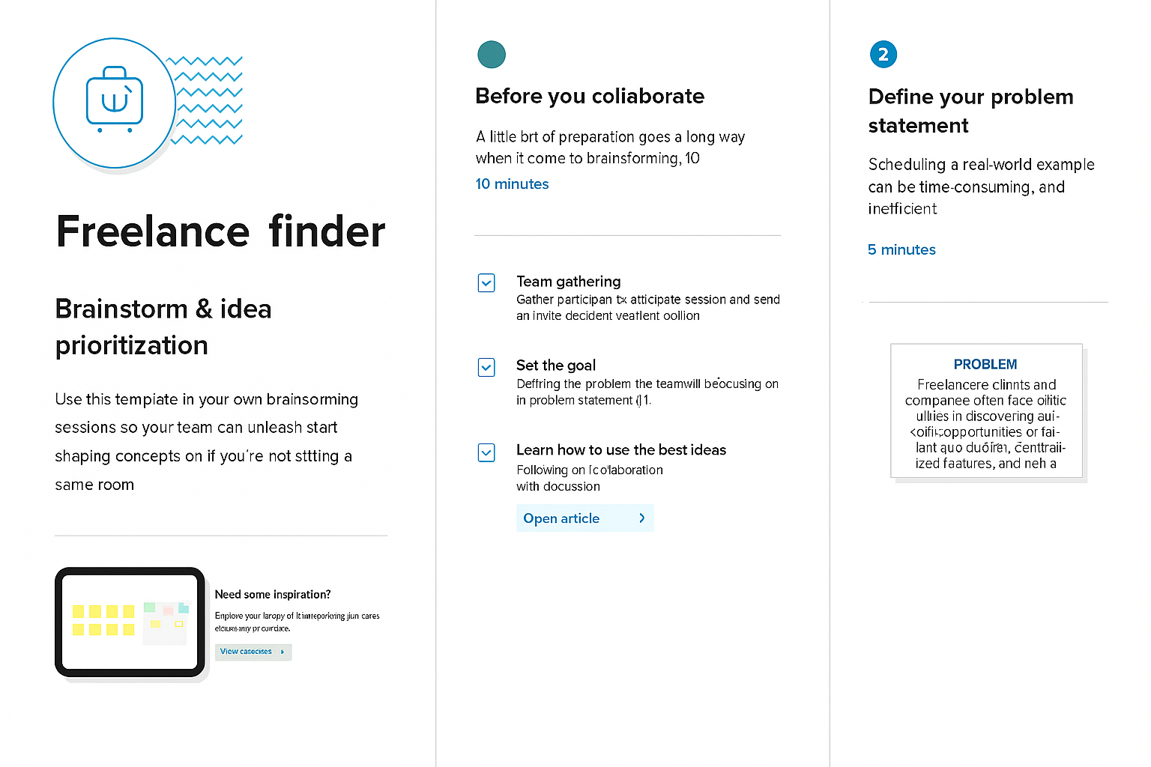

## Step 2: Brainstorming, Idea Listing and Grouping

## ChatGPT Image Jun 27, 2025, 03_30_47 PM.png

## ChatGPT Image Jun 27, 2025, 03_38_29 PM.pngStep 3: Idea Prioritization

